MAKER LAB OOP HOMEWORK PDF
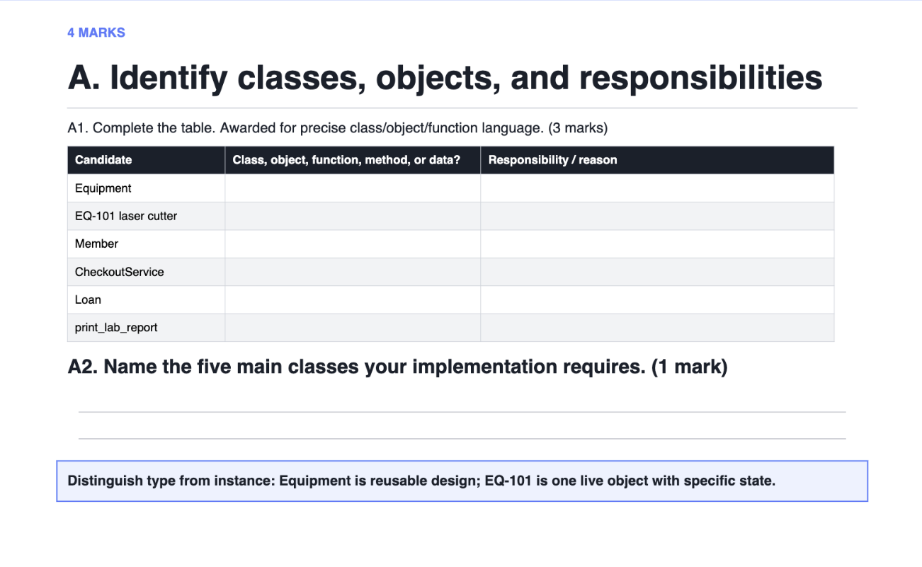
A1 Answer:
Candidate | Class, Object, Function, Method or Data? | Responsibility / Reason
Equipment | Class | Defines reusable blueprint for any lab equipment, attributes and behaviors
EQ – 101 laser cutter | Object | A specific piece of equipment with its own state, asset tag, usage hours and availability flags
Member | Class | Defines what a registered lab member is. Has member_id and name.
CheckoutService | Class | Coordinates the check-out workflow.
Loan | Class | Represent the lifecycle of one checkout transaction, linking a member to an Equipment object and tracking the status of transaction.
print_lab_report | Function | Stand-alone function reports lab status.

A2 Answer:
5 main classes as required for implementation of the assignment are:
- Member
- Equipment
- MakerLab
- Loan
- CheckoutService

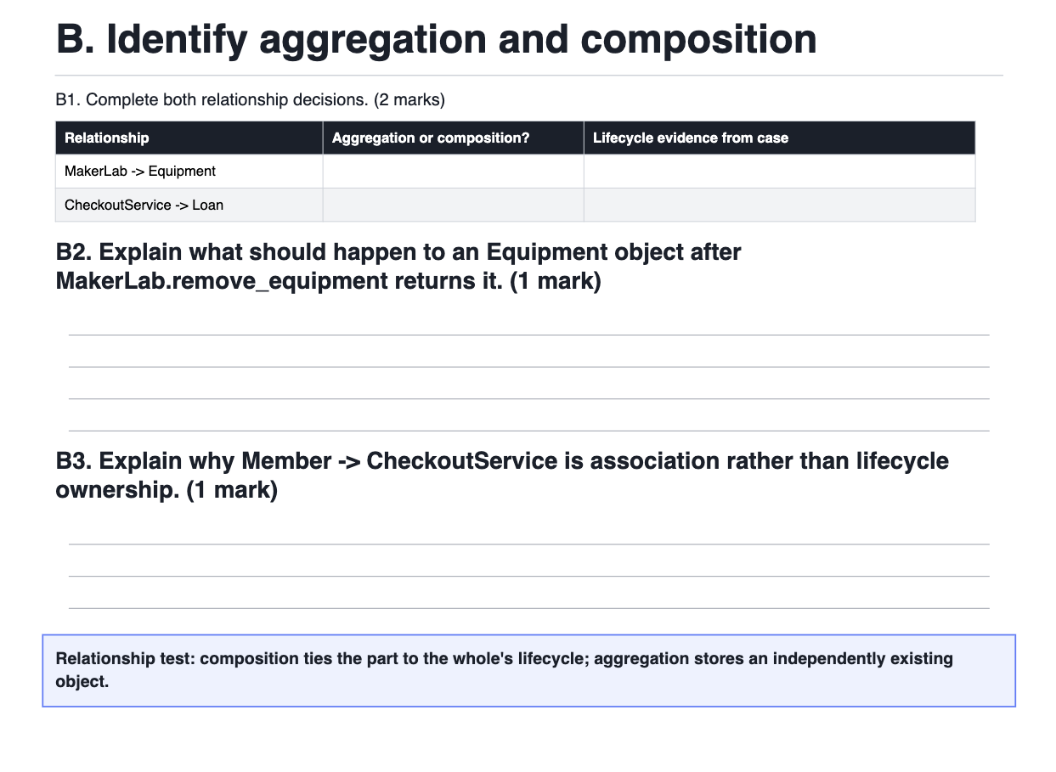
B1 Answer:
Relationship | Aggregation or composition? | Lifecycle evidence from case
MakerLab -> Equipment | Aggregation | remove_equipment explicitly returns the same Equipment object rather than deleting it so the equipment can exist independently of the lab and could be re-added to another lab or collection
CheckoutService -> Loan | Composition | start_loan creates the Loan object itself, inside the service (loan = Loan (member, equipment)). A Loan has no meaning or independent existence outside a CheckoutService managed transaction, and its lifecycle (creation in start_loan, completion/disposal in end_loan) is entirely controlled by the service

B2 Answer:
Because MakerLab -> Equipment is aggregation, the returned Equipment object continues to exist independently after removal it isn't destroyed or invalidated. The caller now owns the only reference to it and is free to keep using it, discard it, or add it to a different MakerLab. The object's own state (asset_tag, usage_hours, availability) is untouched by the removal; only the lab's internal collection has changed.

B3 Answer:
Member -> CheckoutService is association, not composition, because a Member doesn't create, own, or control the lifecycle of a CheckoutService so a Member object is simply passed into CheckoutService.start_loan as an argument. The CheckoutService exists independently of any member (it's constructed with a MakerLab, not a Member), members come and go across many separate calls, and destroying a Member object has no effect on whether the CheckoutService continues to exist. The two classes merely interact through method calls, they don't share a whole/part lifecycle relationship the way CheckoutService -> Loan does.

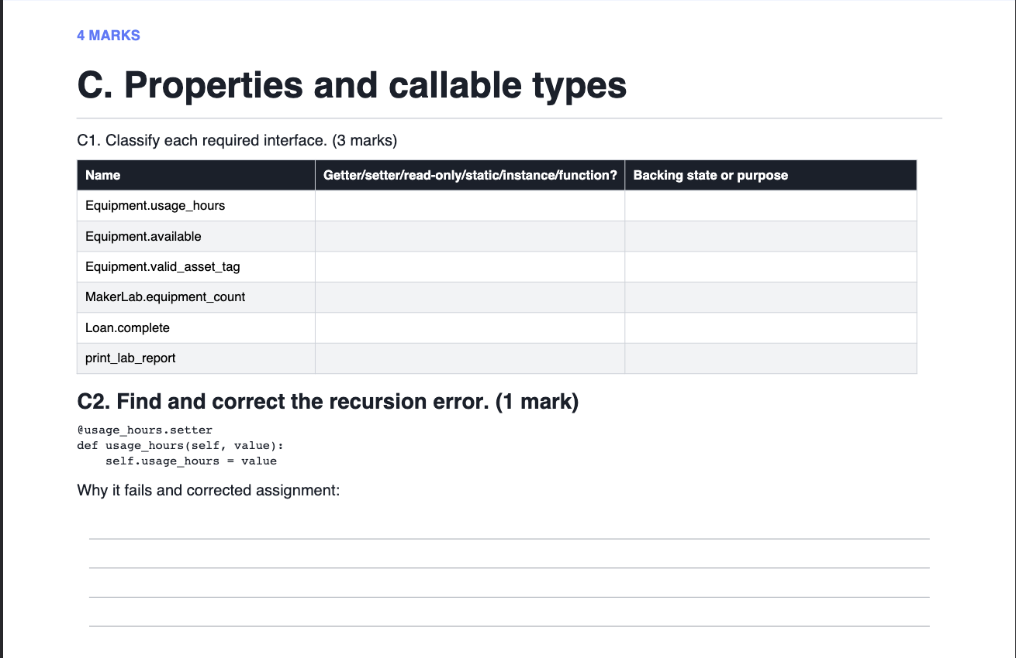
C1. Answer
Name | Getter/setter/read-only/static/instance/function? | Backing state or purpose
Equipment.usage_hours | Getter + setter (instance property, both defined) | Backed by _usage_hours; setter validates type (non-bool int) and rejects negative values before storing
Equipment.available | Read-only property (getter only, no setter) | Backed by _available; deliberately has no public setter so availability can only change through checkout()/return_item()
Equipment.valid_asset_tag | Static method | Not tied to any instance's state; pure validation function checking a candidate string against the asset-tag format rules
MakerLab.equipment_count | Read-only property (getter only) | Backed by _equipment (the list); derived value, exposed with no setter so the count can't be set directly, only observed
Loan.complete | Instance method (function) | Not a property — an action that mutates the loan and its associated equipment; changes _active and delegates usage/availability changes to the Equipment object
print_lab_report | Standalone function | Not a method on any class at all — takes a MakerLab and CheckoutService as arguments and prints a report using their public interfaces
C2 Answer:
Corrected Code:
“
@usage_hours.setter
def usage_hours(self, value):
self._usagehours = value
”

Why it fails? → self.usage_hours = value calls the property’s setter again, because usage_hours is the property name, not the backing field. Every call to setter triggers another call to itself entering a recursive infinite loop.

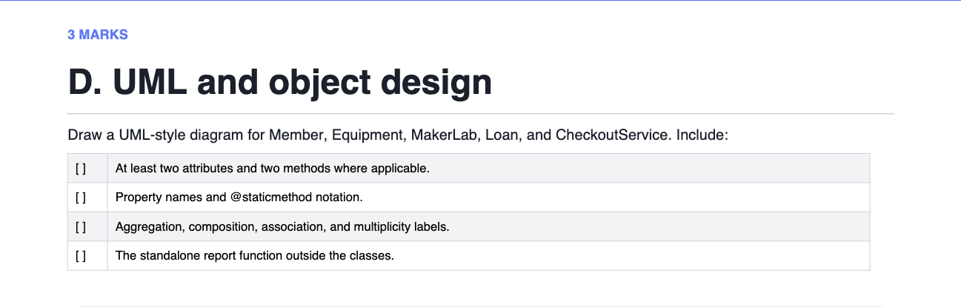
D Answer:
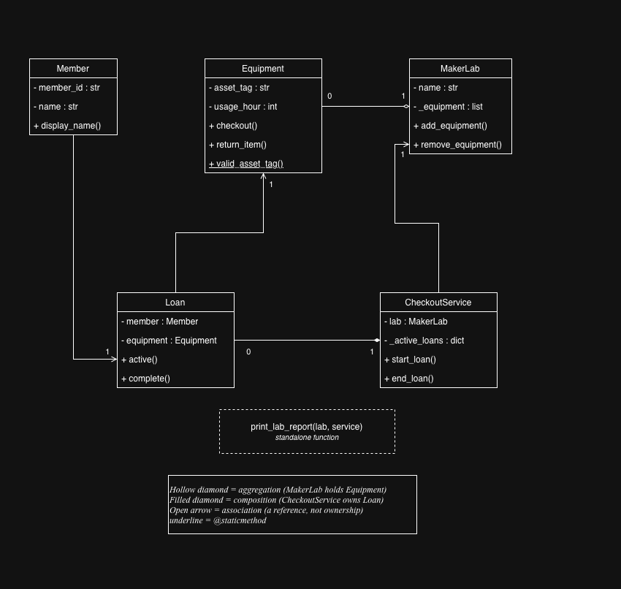
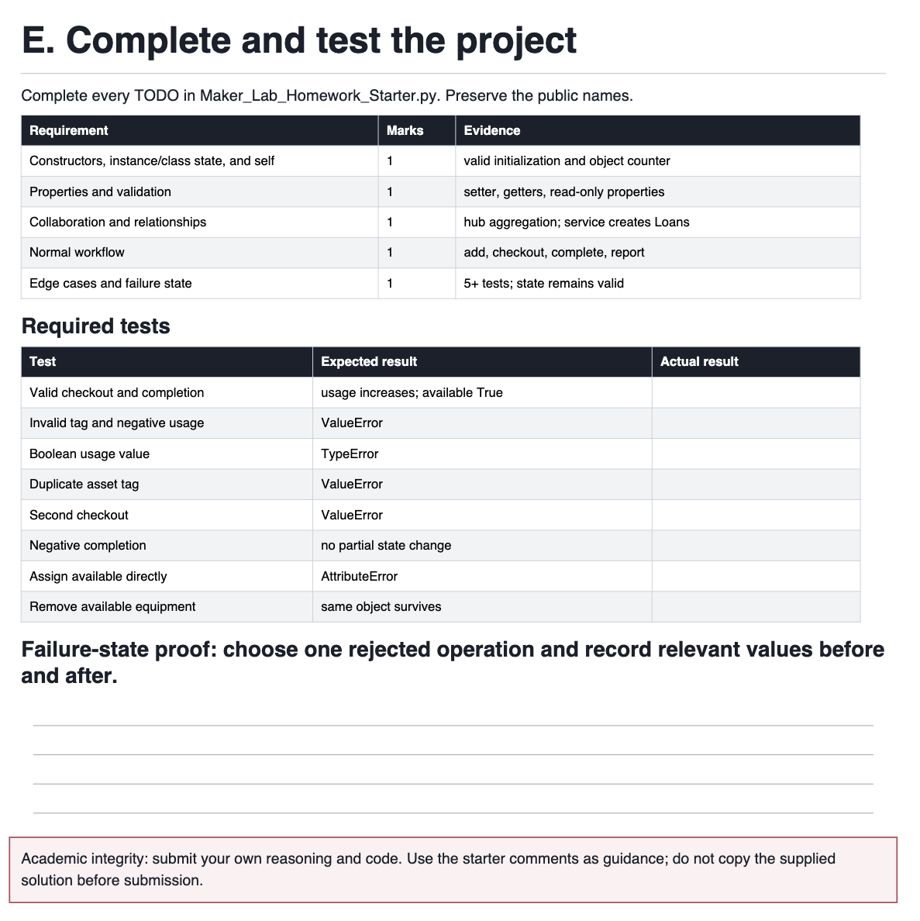
Test | Expected result | Actual result
Valid checkout and completion | usage increases; available True | usage_hours increased, available = True
Invalid tag and negative usage | ValueError | ValueError on both
Boolean usage value | TypeError | TypeError
Duplicate asset tag | ValueError | ValueError
Second checkout | ValueError | ValueError
Negative completion | no partial state change | ValueError raised, usage_hours and available unchanged
Assign available directly | AttributeError | AttributeError
Remove available equipment | same object survives | Same object identity confirmed

